**BURNING CHARACTERISTICS OF BRIQUETTE PRODUCED FROM SAWDUST OF *Ficus exasperata* AND CASSAVA PEEL USING DIFFERENT BINDERS**

K.M. Ogunjobi1, M.U. Chikwendu2 and A.C. Adetogun 3

1,3Department of Forestry and Wildlife Management, Federal University of Agriculture, P.M.B. 2240, Abeokuta, Ogun State, Nigeria.

2Department of Forestry and Environmental Management, Michael Okpara University of Agriculture,P.M.B 7267, Umudike, Abia State, Nigeria.

Corresponding author: 1*[ogunjobikm@funaab.edu.ng,](mailto:ogunjobikm@funaab.edu.ng,2nwogwugwu.michael@gmail.com)[2](mailto:ogunjobikm@funaab.edu.ng,2nwogwugwu.michael@gmail.com)[nwogwugwu.michael@gmail.com](mailto:ogunjobikm@funaab.edu.ng,2nwogwugwu.michael@gmail.com),3adetogunac@finaab.efu.ng*

*+*2348065254590

**ABSTRACT**

*Combustion properties of briquettes produced from sawdust particles of Ficus exasperata and Cassava peel bonded with different binders was evaluated. Energy used for domestic application are increasingly becoming expensive and adoption alternative energy sources is imperative. Sawdust mixed with binders at ratio (60:40) top bond, (40:60) starch and (60:40) cow dung, while cassava peel mixed with binders at ratio (40:60) top bond, (60:40) starch and (40:60) cow dung, followed by admixture of sawdust and cassava peel with the binders at ratio (25:25:50) top bond, (25:25:50) sawdust and (25:25:50) cow dung, and substrate mixed with binders at ratio (20: 20: 20: 20: 20) respectively. Data analysis was carried out using two-way analysis of variance. Proximate composition result reveals that percentage ash content was significant at p<0.05. Results on binders revealed that heating value (HV) was highest at starch(32.48Mj/kg) and lowest in cow dung(30.9Mj/kg) while result on substrate reveals HV at sawdust(32.79Mj/kg) and lowest in cassava peel (30.39) with significant higher % ash content (9.5). Therefore, this study reveals that briquette by admixture of sawdust and cassava peel bonded with starch had the best burning characteristics which encourages bio- wastes used as alternative to energy.*

**Keywords**: Briquette, sawdust*,* Cassava peel, Combustion properties, Binding agents

**INTRODUCTION**

Energy is one of the basic necessities of life. There are several sources of energy which could serve as a preferable replacement for non-renewable energy sources, such as coal and other fossil fuels [1,2]. Biomass as a veritable source of energy is gaining research interest in both developing and developed countries [3,4]. Biomass remains a renewable source of energy which can reduce greenhouse gas emissions compared to fossil fuels, which have detrimentally contributed to global warming [5].

With rapidly rising global energy needs by teeming world population [6], and rapid industrialization and urbanization [7], biomass-to-energy is a promising alternative energy technology [8]. Biomass (woody bio-residue) has gained prominence as one of the widely utilized sources of renewable energy fuel. This advantage is a result of the contribution made to the reduction of net greenhouse gas emission and the security of energy supply [9]. Moreover, woody bio-residues have continued to gain significant interest and attention because of their renewability, greenish, and global availability [10].

Currently, there has been a strong worldwide interest in the development of technologies that can exploit renewable energy sources otherwise known as Green Energy, both for environmental and economic purposes. The rate at which wood is being used is increasing on daily basis especially in the less technologically developed countries of the world, Nigeria inclusive [11]. This has mounted a significant pressure on the declining of forest resources thereby aggravating the level of deforestation in our immediate environment. Therefore, heavy dependence on wood for domestic cooking would not proffer solution to the current energy crisis; rather it would continue to aggravate the level of deforestation which is the illegal felling of trees or over – exploitation of trees or desertification resulting in further scarcity of this resource [12].

Tremendous wood wastes are generated during various wood conversion process either in the form of twigs, edgings, trimmings, slabs and dust. Also, large quantities of agricultural by-products (wastes) are generated. These by-products (wastes) contribute significantly to environmental pollution as they are burnt and when left, they constitute nuisance in the environment hampering visibility and causing health hazard. Whichever way, these contribute to wastage of available energy [13].

Globally, biomass energy has continued to remain an important renewable energy component. It is an important part of national energy mix both for developed and developing countries towards achieving sustainable energy for heating applications, reducing environmental impact, creating bio‐economies, reducing over dependence on fossil fuel, improving quality of rural and urban life, and for the production of various biofuels [14]. One of the challenges with the utilization of biomass is that they are mostly in loose form having low energy density. Agricultural biomass residues have the potential for the sustainable production of bio-fuels and to offset greenhouse gas emissions [15]. Straw from crop production and agricultural residues existing in the waste streams from commercial crop processing plants have little inherent value and have traditionally constituted a disposal problem. In fact, these residues represent an abundant, inexpensive and readily available source of renewable lignocellulosic biomass [15].

Briquetting is a densification process in which loose biomass are compacted under pressure so that the density of biomass residues could be increased up to about 10 0 0–120 0 kg/m 3 and the volume be increased by 8–10 times of the loose biomass [7]. Briquetting process can be categorized base on binder usage or not. Briquetting with or without binder requires applied compaction pressure for biomass densification [16]. The making of fuel briquettes from blends of forest and agro-residues demonstrate the potential of appropriate technology for the use of biomass residues as energy fuel [17,18].

Briquetting biomass is a process involved in the production of the solid block material i.e briquette and this can be done using various techniques, either with or without binder. For charcoal and other biomass material that lacks plasticity, addition of a sticking or agglomerating material, preferably combustible is required to enable the formation of solid briquettes [17,19]. Frequently used binders are starch, top bond, gum arabic, soil, animal dung or waste paper. Biomass briquettes in the developing countries are mainly for household consumption. Biomass briquetting, a densification technology, is one of the technologies used in improving the potential energy use of biomass primarily for household heating applications and power generation [20]. Biomass generally contain naturally occurring structural binders or stabilizing agents, such as lignin and proteins that are released and activated when biomass is densified at relatively high levels of temperature and pressure [18,21].

Briquettes could serve as a substitute to firewood and charcoal for domestic cooking and agro-industrial operation, thereby reducing the high demand for firewood and charcoal in our concerned environment. Besides, briquettes have well known merits over fuel wood in terms of greater heat intensity, cleanliness, convenience in use, and relatively smaller space requirement for storage [14,22].

The enormous quantities of forest and agricultural residues produced in Nigeria can play relevant roles in meeting her energy requirement. Most of these residues are biomass, which contains large amount of energy [23]. However, it is unfortunate that these wastes are neither utilized efficiently nor properly enhance effectively in all developing countries, including Nigeria [24-25]. Instead of allowing wood residues and agricultural by-products to be disposed of ordinarily, there is need to put them into efficient usage through production of solid material i.e. briquette as an alternative means to fuel usage and thereby transform waste to wealth. Therefore, the aim of this research was to evaluate the burning characteristics of briquettes produced from *Ficus exasperata* and cassava peels with various binding agents.

**MATERIALS AND METHOD**

**Study Area**

This study was carried out at the Wood Laboratory Unit of the Department of Forestry and Wildlife Management, Federal University of Agriculture, Abeokuta, Ogun state, Nigeria. The University is located at Alabata road in the North Eastern part of the town, Abeokuta, in Odeda Local Government Area. FUNAAB lies on latitude 70 30'N and longitude 30 54'E. It lies within the humid lowland forest region with two distinct seasons. The mean annual rainfall is 1113.1 mm with mean temperature range of 22.9 OC to 36.32 OC and relative humidity is about 82.54% [26].

**Methodology**

The sawdust particles of *Ficus exasperata* collected was soaked with hot water for 24 hours so as to reduce the extraneous materials found in the sawdust in order to make it easy to agglomerate with the binders and to produce smokeless briquette. After soaking, it was sundried for 2 (two) days so as to reduce the excess moisture and later screened with sieve of constant size which is 2mm to obtain uniform grain size distribution. The cassava peel collected was sundried for 6 (Six) days so as to reduce the moisture content to between 8-12% which is within the acceptable operating limit for briquetting before it was grinded [27-28].

**Substrate and Binding ratio:**

Sawdust particles of *F. exasperata* and Cassava peels were bonded with different binding agents (cassava starch, top bond and cow dung). Sawdust of *F. exasperata* was mixed with the binder in ratio (60:40) for top bond, (40:60) for starch, and (60:40) for cow dung while the cassava peels were mixed with the binder in ratio (40:60) for top bond, (60:40) for starch and (40:60) for cow dung, followed by the combination of sawdust and cassava peels with the binder in ratio (25:25:50) for top bond, (25:25:50) for sawdust, (25:25:50) for cow dung, and the mixture of sawdust, cassava peels mixed with top bond, starch and cow dung in ratio (20: 20: 20: 20: 20) respectively.

**Briquette Production Processes**

Each substrate (i.e. sawdust and cassava peel) and the binders were weighed on the top weighing scale to get their stipulated ratios, then each treatment were thoroughly mixed respectively with the binder(s) and later the mixed treatment(s) were handfed into the locally fabricated rectangular shaped metallic briquette mold (10cm x 5cm) for the formation of briquette where by a hand iron press was used to compress the treatment in other to give it strength and increase the binding ability of the binder in the mixture (treatments). Two replicates of each mixing proportion were produced making a total of 20 samples. The formed briquettes were sundried under the favorable atmospheric condition for complete 21 days in other to obtain suitable moisture content and proximate analyses were investigated. Each sample produced were subjected to test for calorific value. Proximate analysis was carried out on the briquette samples to determine the percentage volatile matter content, % ash content, % content of fixed carbon and heating value of the samples using the formula below and the procedure of ASTM E711-876 [29] were adopted.

**Percentage Ash Content**

The Percentage Ash Content (PAC) was determined by heating 2g of the briquette sample in the furnace at a temperature of 550°C for 4hours and weighed after cooling in a desiccator to obtain the weight of ash (C). The PAC was determined using the Equation below:

𝑃𝐴𝐶 = $\frac{C}{A}100$ (1)

Where C = Weight of the sample

A= Weight of the oven dried sample.

**Percentage Volatile Matter**

The Percentage Volatile Matter (PVM) was determined by pulverizing 2g of the briquette sample in a crucible and placing it in an oven until a constant weight was obtained. The briquettes were then kept in a furnace at a temperature of 550°C for 10minute and weighed after cooling in a desiccator. The PVM was then calculated using the Equation below:

𝑃𝑉𝑀 = $\frac{A-C}{A}100$ (2)

Where C = Weight of the sample after 10min in the furnace at 550°C.

A = Weight of the oven dried sample

**Percentage Fixed Carbon**

Fixed Carbon = $100\%-\left(PAC+PVM\right)$ (3)

Where % **V** = percentage volatile matter

% **A** = percentage ash content

**Heating Value/ Caloric Content**

Specific Heat of Combustion (HC) was calculated using the formula:

Hc = $2.326 \left(147.6c+144 v\right)$ (4)

Where:

**HV**= Heating value

**C** =Percentage fixed carbon

**V** =Percentage volatile matter (ASTM, D3175-18), [30]

**Statistical Analysis**

An analysis of variance (ANOVA) test was used subjected to two-way analysis of variance at P < 0.05. Significant differences between variables were determined using Duncan Multiple Range Test (DMRT0.05) to separate the variable means at P < 0.05 Descriptive statistics was also carried out on the data. All analysis was done with SPSS v20 (Statistical Packages for Social Sciences).

**RESULTS**

Table 1 shows the RCBD (Two-way ANOVA) of briquette properties according to the substrates and the binders. The result revealed that there was no significant difference (P>0.05) in the effects of the substrates (Sawdust and Cassava Peel) on the proximate properties. However, for the binders, there are significant differences (P<0.05) in the effects of the binders on the proximate properties except for PAC where no significant difference (P>0.05) was observed. DMRT0.05 was used to determine which of the binders differs from one another based on the volatile matter; (%) fixed Carbon and the heating values but not based on the (%) ash content since they have the same effect based on the ash content. The result revealed that, there were significant differences between starch and cow dung, while that of starch and top bond are the same. Also, that of top bond and cow dung also differs.

**Table 1**: **Showing the proximate composition of the briquettes according to the substrates and different binders.**

|  |  |  |  |  |  |  |
| --- | --- | --- | --- | --- | --- | --- |
| Sources of Variation | DF | SS | MS | F Cal | P-Value | F-Crit |
| Substrates | 1 | 24.0 | 24.0 | 1.71 | 0.21 | 18.51Ns |
| %VM Binders | 2 | 41984.5 | 2099.45 | 1499.45 | 0.01 | 19.0٭٭٭ |
| Error | 2 | 28.0 | 14.0 |  |  |  |
| Total | **5** | **42036.5** |  |  |  |  |
| Substrates | 1 | 40.04 | 40.04 | 4.20 | 0.07 | 18.51Ns |
| %ASH Binders | 2 | 347.63 | 173.82 | 18.20 | 0.177 | 19Ns |
| Error | 2 | 19.08 | 9.54 |  |  |  |
| Total | **5** | **406.75** |  |  |  |  |
| Substrates | 1 | 2.042 | 2.042 | 0.505 | 0.21 | 18.51Ns |
| %C Binders | 2 | 578.13 | 289.06 | 71.55 | 0.04 | 19٭٭ |
| Error | 2 | 8.08 | 4.04 |  |  |  |
| Total | **5** | **588.25** |  |  |  |  |
| Substrates | 1 | 4.54 | 4.54 | 4.284 | 0.10 | 18.51Ns |
| HV Binders | 2 | 5874.26 | 2937.13 | 2770.87 | 0.03 | 19٭٭٭٭ |
| Error | 2 | 2.12 | 1.06 |  |  |  |
| Total | **5** | **5876.38** |  |  |  |  |

٭٭٭٭Significant if (F-Cal. > F- Crit.), Ns-Not significant (F-Cal. < F-Crit)

**Mean proximate analysis of the briquettes according to the binders**

The mean effect of the binders based on the briquette’s properties were presented in the Table 2 below. The mean volatile matter recorded was 83.5 ± 6.14. Starch had the highest (88.0 ± 2.0), followed by Top Bond (86.0 ± 3.83) while cow dung had the least (76.5 ± 7.42). Mean percentage Ash content was 19.67 ± 22.06. Though there was no significant difference in the amount of ash produced by the briquettes for all the binders, the highest was obtained with the use of top bond (44.75 ± 46.66) followed by Cow dung (11.0 ± 6.63) while starch had the least (3.25 ± 0.96) percentage ash content. Mean percentage carbon content was 10.42 ± 4.02 and cow dung had the highest (15.0 ± 4.08) followed by starch (8.75 ± 2.87) while Top bond had the least (7.5 ± 2.38). Briquette produced with starch had the highest heating value followed by that produced with Top bond (31.38 ± 0.79) and the cow dung (30.9 ± 3.63) had the least. The Duncan test showed that there are significant differences in the fixed carbon, percentage (%) volatile matter and heating value effects of briquettes produced by the binders (p<0.05).

**Table 2: Mean proximate analysis of the briquettes according to the binders**

|  |  |  |  |  |
| --- | --- | --- | --- | --- |
| Proximate composition | | | | |
| Binders | **%Volatile Matter** | **%Ash** | **%Carbon** | **Heating Values** |
| Starch | 88.0 ± 2.0a | 3.25 ± 0.96 Ns | 8.75 ± 2.87a | 32.48 ± 0.34a |
| Top Bond | 86.0 ± 3.83b | 44.75 ±46.66 Ns | 7.5 ± 2.38b | 31.38 ± 0.79b |
| Cow dung | 76.5 ± 7.42c | 11.0 ± 6.63 Ns | 15.0 ± 4.08c | 30.9 ± 3.63c |
| Mean | 83.5 ± 6.14 | 19.67 ± 22.06 Ns | 10.42 ± 4.02 | 31.58 ± 0.81 |

There is significant difference in means with the same letter along the column at (P< 0.05).

**Mean proximate analysis of the briquettes according to the substrates and the mixture**

The mean effect of the substrates (Sawdust and Cassava peel) based on the briquette’s properties were presented in the Table 3 below. Average volatile matter was 82.28 ± 2.91. The highest value was recorded for sawdust (85.5 ± 5.43) followed by cassava peel (81.5 ± 8.09) while the mixture had the least (79.83 ± 5.49). Average percentage ash content was 6.67 ± 2.62 and cassava peels recorded the highest (9.5 ± 5.99) followed by mixture (6.17 ± 3.76) while sawdust had the least (4.33 ± 1.63) percentage ash content. Mean percentage carbon produced by the substrates was 11.05 ± 1.80. However, the mixture had the highest percentage carbon (12.33 ± 3.2) followed by sawdust (11.83 ± 5.71) and cassava peels had the least (9.0 ± 2.61). Mean heating value was 31.33± 1.28MJ/Kg. Briquette produced by sawdust had the highest heating value (32.79 ± 1.41) MJ/Kg followed by that produced with the mixture (30.81 ± 1.77) MJ/Kg and that produced with cassava peel had the least (30.39 ± 1.98) MJ/Kg.

**Table 3: Mean proximate analysis of the briquettes according to the Substrates and the mixture**

|  |  |  |  |  |
| --- | --- | --- | --- | --- |
| Proximate composition | | | | |
| Substrate | **%Volatile Matter** | **%Ash** | **%Carbon** | **Heating Values** |
| Sawdust | 85.5 ± 5.43 | 4.33 ± 1.63 | 11.83 ± 5.71 | 32.79 ± 1.41 |
| Cassava peel | 81.5 ± 8.09 | 9.5 ± 5.99 | 9.0 ± 2.61 | 30.39 ± 1.98 |
| Mixture | 79.83 ± 5.49 | 6.17 ± 3.76 | 12.33 ± 3.2 | 30.81 ± 1.77 |
| Mean | 82.28 ± 2.91 | 6.67 ± 2.62 | 11.05 ± 1.80 | 31.33±1.28 |

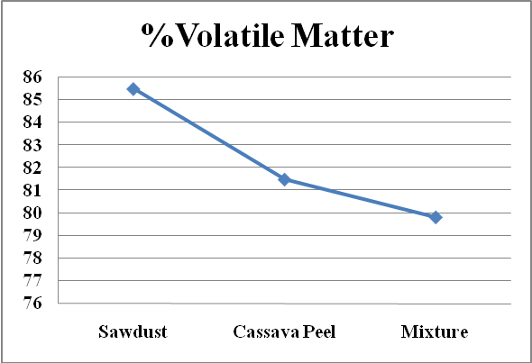

**Fig1: Briquettes mean substrates and the mixture of Percentage volatile matter (PVM).**

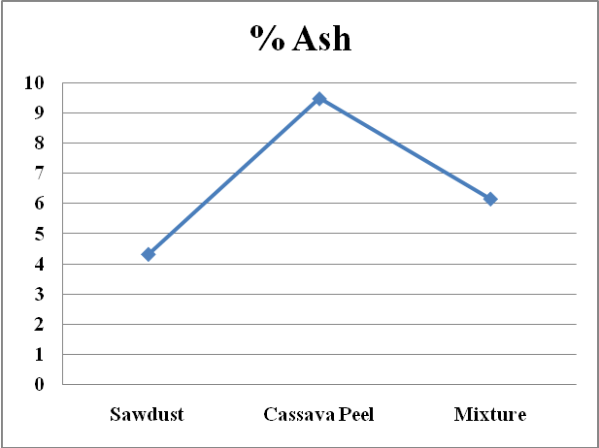

**Fig 2: Briquettes mean substrates and the mixture of Percentage ash content (PAC).**

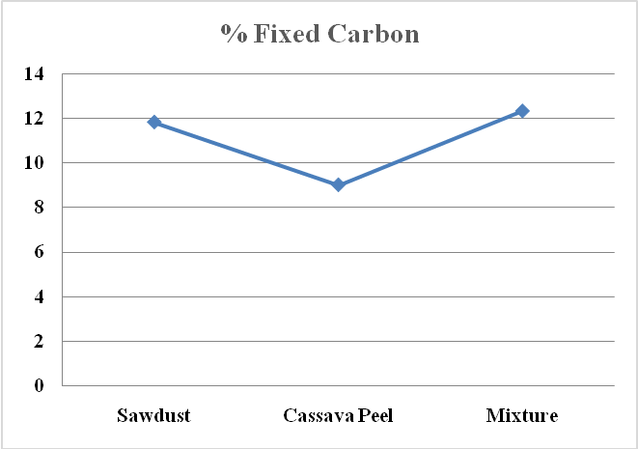

**Fig 3: Briquettes mean substrates and the mixture of Percentage fixed carbon(PFC).**

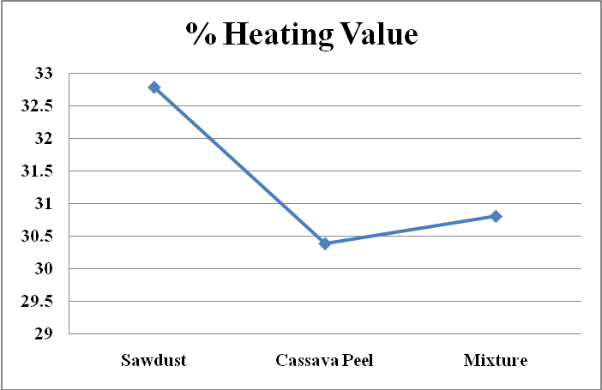

**Fig 4: Briquettes mean substrates and the mixture of the Heating value (HV).**

**DISCUSSION**

From the result of analysis conducted on the briquette produced with different substrates and binders, the heating value/calorific content produced from the mixture of sawdust and cassava peels using cassava starch as a binder gave the best physical and combustible property when compared with those produced from sawdust, cassava peel using cassava starch, top bond and cow dung. The heating value produced by the mixture of sawdust and cassava peel bonded with starch is 33.11MJ/kg, this is within the range of 33.09 MJ/kg and 30075.39-31796.94 kJ/Kg recorded by [27,31], on rice husk, maize cob, groundnut shell and sugar cane bagasse. The result compares favourably with the results of the heating value reported by and [20] on sawdust and Biomass Briquette Binders and Quality. The calorific values of the briquettes were in the range of 19.4–24.9 MJ/kg. [6]. This could be as a result of the initial carbonization of the charcoal. Heating value determines the energy content of a fuel. It is affected by the chemical composition and moisture content. It is the most important fuel property [32]. The heating value from this result proves to be suitable for domestic use such as cooking, barbequing and small- scale cottage application [33]. The calorific value determines the amount of heat energy present in a material, from the result of the study the highest calorific value was seen in sawdust at value of 32.79±1.41MJ/kg shown in table 3. and lowest in cassava peel with value of 30.39±1.9832.79±1.41MJ/kg. these differences from other study findings could be attributed to manufacturing conditions such as temperature and pressure can influence the values [34]. High percentage fixed carbon of 12% recorded for the mixture must have been responsible for the high heating value obtained from the mixture of sawdust and cassava peel bonded with starch. This is due to the fact that carbon supports combustion of materials. The presence of starch content also has a major effect on the burning and heating value of the briquette produced. The increase in fixed carbon when compared to the overall constituents is most likely due to the concentration of binders in briquette preparations [33],[35]. The amount of volatile matter therefore strongly influences the thermal decomposition and combustion behavior of solid fuels i.e. briquette. Volatile matters are gases that are expelled out during combustion, these gases include CO2, CH4, SO2 and ash content generally expressed on dry basis. It is the inorganic matter left out after complete combustion of the biomass. From the result, the values of volatile matter and ash content of 84.5 % and 2.5% respectively are good and acceptable when compared with 3.35% of ash content and 84.7% of volatile matter recorded by [36] with percentage fixed carbon 11.95. The sample with the least volatile matter is expected to have the highest percentage of fix carbon and the highest Volatile matter will have highest heating value [34].

The analysis conducted in this study showed that the briquette made by the mixture of sawdustof *Ficus exasperata* and cassava peel using cassava starch has higher heating values than the durian peel conducted by[37] with the heating value of 20.265MJ/Kg and compares favourably with the results of the heating value of sawdust briquette obtained by[38] and other researchers like[39] whose finding on heating mean value agrees at 32.43mj/kg which worked on the following biomass briquettes produced from Bio Char sawdust from *Gmelina* *arborea*. The knowledge of ash content tells the extent of clogging up of the medium. From the result of the study high ash content of cassava peel was 9.5±5.99 decreases burning rate and reduces heating value of fuel at 30.39±1.98 as seen in the table 3, which confirmed a similar report of [34],[40].

**CONCLUSION**

The following conclusions were deduced based on the experiment investigations.

1. From this study, it was clear that both the sawdust of *Ficus exasperata* and cassava peels successfully produced briquettes which could serve as an alternative to kerosene and gas whose costs are increasing at an alarming rate which would also reduce the increasing pressure on the forests.
2. Combination of briquettes with admixture of sawdust and cassava peels exhibited best properties from the study and the quality of the briquette produced was influenced by both the types of biomass material and binding agents that was used as starch to produce the best briquettes according to ASTM, D3175-18.
3. The quality of the briquettes that was produced using starch as a binder were higher than those bonded with top bond and cow dung and the fuel generated by the briquettes is eco-friendly i.e. the releases lesser amount of carbon to the atmosphere which minimize the health hazard resulting from the use of fuel wood.

**REFERENCES**

[1] World Bioenergy Association “Global Bioenergy Statistics”, 2019.

[2] Sanchez, P.D.C, Aspe, M.M.T and Sindol, K.N. “An Overview on the Production of Bio-briquettes from Agricultural Wastes” Methods, Processes, and Quality. *Journal of Agricultural and Food Engineering* 1, 2022, pp. 0036.

[3] Brožek, M., Nováková, A. and Kolářová, M. “Quality evaluation of briquettes made from wood waste”, *Res. Agr. Eng*., 58(1), 2012), pp. 30–35. <https://doi.org/10.17221/33/2011-RAE>

[4] Fadele, O.K., Amusan ,T.O., Afolabi, A.O., and Ogunlade C.A. “Characterisation of a briquette from forest wastes” Optimisation approach. Res*. Agr. Eng., 67,*2021, pp. *138–147.* <https://doi.org/10.17221/6/2021-RAE>

[5] Oluwaseyi, K. F, Temiloluwa, O. A, Ademola, O. A and Clement, A. O. “Characterisation of briquettes from forest wastes” Optimisation approach. *Research in Agricultural Engineering, 67 (3),* 2021, pp. *138–147.*

[6] Ajimotokan, H.A., Ehindero, A.O., Ajao, K.S., Adeleke, A.A, Ikubanni, P.P. and Shuaib-Babata, Y.L. **“**Combustion characteristics of fuel briquettes made from charcoal particles and sawdust agglomerates”. *Scientific African 6*,2019, *Elsevier*.

[7] Obi, O. F, Okongwu, K.C. “Characterization of fuel briquettes made from a blend of rice husk and palm oil mill sludge, Biomass Conv”. *Bioref*. 6 (3),2016, pp. 449–456.

[8] Amoo, O.M and Fagbenle, R. L “Renewable municipal solid waste pathways for energy generation and sustainable development in the Nigerian context”*, Int. J. Energy Environ. Eng. 4 (42),* 2013, *pp.1–17.*

[9] Eddine, B.T. and Salah, M.M. “Solid waste as renewable source of energy” Current and future possibility in Algeria. *Int. J. Energy Environ. Eng.* 3 (17) 2012, pp. 1–12.

[10] Soponpongpipat, N. and Sae-Ueng, U. “Effect of biomass bulk arrangements on the decomposition pathways in the torrefaction process”*, Renew. Energy,* 81, 2015, pp. 679–684.

[11] Aremu, M.O and Agarry, S.E. “Enhanced Biogas Production from Poultry Droppings using Corn Cob and Waste Paper as Co-Substrates”, *International Journal of Engineering Science and Technology; 5(2)*,2013, pp. *247-253.*

[12] Salunkhe, D.B, Rai, R.K, and Borkar, R.B. “Biogas technology”, *International Journal of Engineering Science and Technology, 4(12),*2012, pp. *4934-4940.*

[13] Oladeji, J.T. “Fuel characterization of briquettes produced from corncob and rice husk resides”. *Pac. J. Sci. Technol. 11(1),*2010, pp. *101–106*.

[14] Hoang, A.T., Ong, H.C., Fattah, I.R., Chong, C.T., Cheng, C.K., Sakthivel, R., and Ok, Y.S. “Progress on the lignocellulosic biomass pyrolysis for biofuel production toward environmental sustainability”. *Fuel Process. Technol.*, *223*, 2021, pp.106997.

[15] Kuti, O.A and Adegoke, C.O. “Comparative performance of composite sawdust briquette with kerosene fuel under domestic cooking conditions”, Assump. *Uni. J. Technol*. 12 (1), 2008 pp.57–61.

[16] Adetogun, A.C Ogunjobi, K.M and Are, D.B. “Combustion properties of briquettes produced from maize cob of different particle sizes,” *Journal of Research, Forest, Wildlife Environment, 6,* 2014, pp. *28–38.*

[17] Fikremariam, H, . Gemechu,Y, and Mahelete *et al.,* “Production and characterization of briquettes from carbonized Cupressus lusitanica sawdust with different organic binders,” *International Journal of Recent Scientific Research, 11(12),* 2020, pp. *40189–40194.*

[18] Obi, O.F. “Evaluation of the physical properties of composite briquette of sawdust and palm kernel shell”. *Biomass Convers. Biorefin.*, *5*, 2015, pp. 271–277.

[19] Osadolor, O.O. “Performance Evaluation of Different Briquettes produced from Wood and Agricultural Wastes, *Journal of Engineering Science and Applications*, 4 (2), 2006, pp 90-95.

[20] Obi, O.F., Pecenka, R. and Clifford, M. J. “A Review of Biomass Briquette Binders and Quality Parameters”. *Energies*, *15*, 2022, pp. 2426. <https://doi.org/10.3390/en15072426>

[21] Oyelaran, O.A., Bolaji, B.O., Waheed, M. A. and Adekunle, M. F. “Performance evaluation of the effect of binder on groundnut shell briquette”. *Appl. Sci. Eng. Prog.*, *8*, 2015, pp.11–19.

[22] Barranco, C. and Mendoza J., “Elaboración de biocombustibles sólidos densificados a partir de tusa de maíz, bio aglomerantes de yuca y carbón mineral del departamento de Córdoba, Ingeniería, 25 (4),2016, pp. 643-653.

[23] Babajide, F.V., Oluwaseyi O. A. and Rivi, D., “NPerformance evaluation of the physical and combustion properties of briquettes produced from Ago- wastes and wood residues” Recycling, 3 (3) ,2018.

[24] Roni, M., Chowdhury, S., Mamun, S., Marufuzzaman, M., Lein W., and Johnson, S., “Biomass co-firing technology with policies, challenges, and opportunities”. A global Review. Renewable and Sustainable energy reviews, 78, 2017, pp. 1089-1101.

[25] Deniz, V. A.,” New binder in production of water- resistant briquettes from bituminous coals”Co- polymer binder, Energy Sources, Part A: Recovery, Utilization, and Environmental Effects, 38(8), 2016, pp.1068-1074.

[26] Ufoegbune, G.G. and Fabiyi, S. “Identification of Land Areas suitable for FADAMA at Federal University of Agriculture, Abeokuta, Nigeria using GIS”, *Journal of Applied Sciences and Environmental Management*, 20 (4), 2016, pp. 1027-1032.

[27] Abera T. E. “Production and Characterization of Coffee Husk and Sawdust Briquettes with Potato Peel, Waste Paper and Molasses as a Binding Material”. *International Journal of Scientific & Engineering Research. 10 (8),* 2019, pp.*1281-1290.*

[28] Davies, R.M,.” Some Physical and Mechanical Characteristics of Briquettes of White Afara (Ter-*minalia* *superba*) Sawdust and Organic Binders,” *International Journal of Scientific Research in Ag-ricultural Sciences,* vol. 2(3), 2015, pp.55-60.

[29] ASTM standard E711-87. “Standard test method for gross caloric value of refuse – derived fuel by the bomb calorimeter”. Annual book of ASTM standard, 11.04. ASTM International, http//www.astm.info/standard/E711.htm**.** 2004.

[30] ASTM, D3175-18. “Standard Test Method for Volatile Matter in the Analysis Sample of Coal and Coke”, ASTM International, West Conshohocken, PA, USA. 2018.

[31] Idah, P.A, and Mopah, E.J. “Comparative assessment of energy values of briquettes from some agricultural by-products with different binders*” IOSR J. Eng. 3 (1)*,2013, pp.*36–42*.

[32] Aina, O., Adetogun, A and Iyiola, K. “Heat Energy from Value-Added Sawdust Briquettes of Albizia Zygia”*.* Ethiopian Journal of Environmental Studies and Management, 2(1), 2009 Pp.42-49.

[33] Emerhi, E. A. “Physical and combustion properties of briquettes produced from sawdust of three hardwood species and different organic binders”. *Adv. Appl. Sci. Res., 2(6),*2011, pp. *236-246.*

[34] Imeh E.O., Ibrahim A.M., Alewo O.A., Stanley I.R. and Opeoluwa O.F., “Production and characterization of biomass briquettes from tannery solid waste”. *Recycling* 2(17), 2017, pp.1-19.

[35] Olugbade, T., and Ojo, O. “Mohammed, T. Influence of binders on combustion properties of biomass briquettes” A recent review. *BioEnergy Res.* (*12)*, 2019, pp. 241–259.

[36] Sotande, O.A., Oluyege, A.O. and Abah, G. B. “Physical and combustion properties of briquette of sawdust from *Azadiratha* *indica* , *Journal of Forestry Research,* 21 (1), 2010, pp. 377-381

[37] Awulu, J.O.,Omale, P.A and Ameh, J.A. “Comparative Analysis of Calorific Values OF Selected Agricultural wastes. *Nigerian Journal of Technology (NIJOTECH).37(4)*,2018 pp. 1141 – 1146

[38] Chaiklangmuang, S., Supa, S and Kaewpet, P.” Development of fuel briquettes from biomass-lignite blends”*.* Chiang Mai J. Sci, 35(1), 2008, pp. 43-50.

[39] Adegoke, I.A and Ogunsanwo, O. Y. “Thermal energy estimate of briquettes produced from biochar sawdust of *Gmelina* *arborea*. American Association for Science and Technology 4(1), 2017, pp.1-4.

[40] Grover, P.D, Mishra, S.K. and Clancy, J.S. “Development of an appropriate biomass briquetting technology suitable for production and use in developing countries”. *Energy Sustain. Dev*. 1(1), 1994, pp. 45–48.